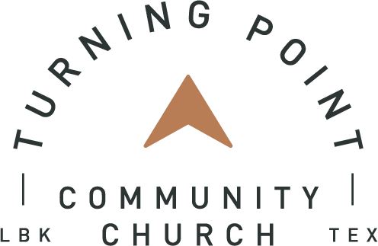
Turning Point Community Church
Job Description

Job Title: Kids’ Ministry Teacher
FLSA Status: Part-Time, Non-Exempt
Workdays/Hours: Sundays 7:30 am- 1:00 pm; 10 hours per week.
Weekend Responsibilities: This position has regularly scheduled weekend responsibilities as assigned by the Kids Pastor and a rotation of periodic weekends off will be established to give a healthy margin and rest.
Reports To: Kids Pastor

MINISTRY PURPOSE: Responsible for supporting and assisting the Kids’ Pastor in the advancement of the Kids’ Ministry (KM) vision and direction by teaching on Sunday mornings. All duties, tasks and interactions should keep with Turning Point Community Church’s mission of “Changed Lives. Period.”

MINISTRY QUALIFICATIONS:

Character:

- A follower of Jesus Christ who is growing spiritually and serving as a leader within the body of Christ.
- Demonstrate a lifestyle and family life that is consistent in word and practice with the teaching of Jesus Christ. Consistently meets and strives to maintain the leadership character qualifications as outlined in 1 Timothy 3 (“above reproach, sober minded, self-controlled, respectable, hospitable, able to teach...filled with gentleness.”)
- Understand and embrace TPCC’s mission, purposes, and vision for ministry.
- Possess an inspirational and influential personality that champions the needs of children and families.
- Advance TPCC’s culture of grace seeking unity in the essentials, charity in the nonessentials and exalting Christ in all things.

Competency – Skills:

- Possess a high degree of initiative in both tasks and relationship building to help equip volunteer teams.
- Understand the unique discipleship and logistical needs of a growing Kids’ Ministry.
- Navigate wisely and professionally between the goals of the Kids’ Ministry, ministry leaders, volunteers, and the concerns of individual parents.
- Communicate in a professional, polished, and discerning manner across various modes of contact: face-to-face, phone, text, email, social media, etc.
- Ability to always maintain the highest degree of discernment and confidentiality.

Chemistry – Relational Abilities:

- Appreciate the God-given personalities and spiritual giftedness of others, exercising both a spirit of discernment and deference.
- Resolve relational and professional conflicts in an expeditious manner while extending and receiving forgiveness.
- Develop intentional, positive relationships with the KM Team, parents, and children.
- The ability to work hard until the job has been completed to meet deadlines and anticipate pivots as they occur.

Job Responsibilities:

- Comfortable with leading and facilitating the bible teaching, worship time and memory verse activities on Sunday morning in the children’s rooms as directed by the Kids Pastor.
- Comfortable in leading small groups and discussion with children on Sunday mornings.
- Meet with the Kids’ Pastor on a monthly basis to discuss assignments, task, work performed, progress, and to request assistance.

MINIMUM QUALIFICATIONS

Education:
Minimum High School Diploma; 1-2 years’ experience in a full-time job.

Experience:
Leadership experience in a church environment within the kid’s ministry area preferred.

Skills: Excellent written, verbal, and interpersonal communication skills. Ability to always maintain the highest degree of discernment and confidentiality.

Physical Requirements:
Periods of time spent sitting, standing, walking, kneeling, bending, and stooping. Mobility to move from one office area to another within the Church campus and to off-Campus locations. Moderate lifting and carrying may be required. Ability to reach above shoulders, to extend arms, and reach. Ability to climb a ladder. Manual dexterity sufficient to type, operate general office equipment and to file. Specific visual acuities include close vision, distance vision, color vision, depth perception and the ability to adjust focus.

